Case Study 53: Food Waste Monitoring System
Author: Radhasahithi Challa
1. Problem Statement
Food waste is a major problem in hostels, restaurants, cafeterias, and other food-serving establishments. Large quantities of food may be wasted when more meals are prepared than are needed.
The Food Waste Monitoring System uses Python to compare the number of meals prepared, meals served, and leftovers over several days. It calculates the food wastage percentage, identifies days when wastage exceeds the acceptable limit, and generates a daily report to help reduce food waste.
2. Objectives
- To record the number of meals prepared and served each day.
- To calculate leftover meals.
- To calculate the food wastage percentage.
- To identify days that exceed the acceptable wastage limit.
- To display daily food waste reports.
- To help improve meal planning and reduce unnecessary food preparation.
3. Assumptions
- The system monitors food consumption over several days.
- The number of meals prepared must be greater than zero.
- Meals served cannot exceed meals prepared.
- Leftover meals are calculated as prepared meals minus served meals.
- The wastage percentage is calculated using the number of meals prepared.
- The acceptable wastage limit is set to 10%.
- A day is flagged if its wastage percentage is greater than 10%.
- All meal quantities are non-negative whole numbers.
4. Algorithm
- Start the program.
- Set the acceptable wastage limit to 10%.
- Input the number of days to monitor.
- For each day, input the number of meals prepared and served.
- Validate the input values.
- Calculate leftover meals:
Leftovers = Meals Prepared − Meals Served
7. Calculate wastage percentage:
Wastage Percentage = (Leftovers / Meals Prepared) × 100
- Compare the wastage percentage with the acceptable limit.
- If the percentage exceeds 10%, mark the day as High Waste; otherwise, mark it as Acceptable.
- Display the daily report.
- Calculate the overall wastage percentage for all monitored days.
- Display the total number of high-waste days.
- Stop the program.
5. Flowchart
START
Set Acceptable Limit to 10%
Input Number of Days
Enter Meals Prepared and Served
Calculate Leftovers and Wastage %
Is Wastage Greater Than 10%?
No
Mark as Acceptable
Yes
Mark as High Waste
Display Daily and Overall Report
STOP
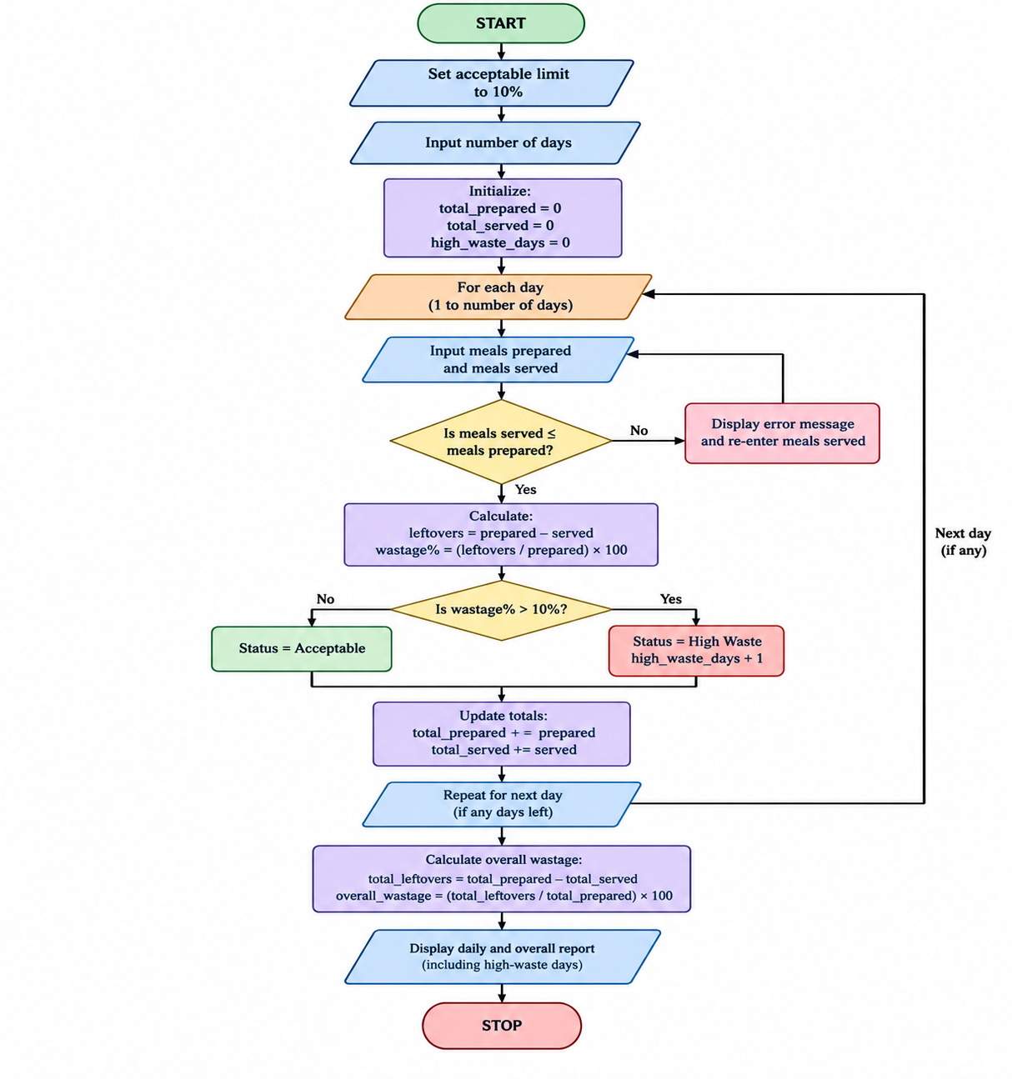
6. Pseudocode
START
SET acceptable_limit = 10
INPUT number_of_days
SET total_prepared = 0
SET total_served = 0
SET high_waste_days = 0
FOR each day:
INPUT meals_prepared
INPUT meals_served
VALIDATE inputs
CALCULATE leftovers = meals_prepared - meals_served
CALCULATE wastage_percentage =
(leftovers / meals_prepared) * 100
IF wastage_percentage > acceptable_limit:
SET status = "High Waste"
INCREMENT high_waste_days
ELSE:
SET status = "Acceptable"
DISPLAY daily report
ADD meals_prepared to total_prepared
ADD meals_served to total_served
CALCULATE total_leftovers =
total_prepared - total_served
CALCULATE overall_wastage_percentage =
(total_leftovers / total_prepared) * 100
DISPLAY overall report
DISPLAY high_waste_days

STOP
8. Explanation of the Code
- ACCEPTABLE_LIMIT = 10.0 sets the maximum acceptable wastage percentage.
- read_integer() validates user input and prevents negative quantities.
- number_of_days specifies how many days will be monitored.
- leftovers calculates the difference between meals prepared and meals served.
- wastage_percentage calculates the percentage of prepared meals left over.
- status indicates whether the daily wastage exceeds the acceptable limit.
- total_prepared and total_served keep track of the totals across all days.
- overall_wastage calculates the wastage percentage for the complete monitoring period.
9. Test Cases
Test | Meals prepared | Meals served | Leftovers | Wastage | Expected status
1 | 100 | 95 | 5 | 5% | Acceptable
2 | 100 | 85 | 15 | 15% | High Waste
3 | 200 | 180 | 20 | 10% | Acceptable
4 | 50 | 40 | 10 | 20% | High Waste
5 | 80 | 80 | 0 | 0% | Acceptable
6 | 100 | 110 | Invalid | Invalid | Rejected by validation
10. Sample Output
For three days, enter the following data:
- Day 1: 100 meals prepared, 95 served.
- Day 2: 100 meals prepared, 80 served.
- Day 3: 200 meals prepared, 180 served.
Enter number of days: 3

Day 1
Meals prepared: 100
Meals served: 95
Meals prepared: 100
Meals served: 95
Leftover meals: 5
Wastage percentage: 5.00%
Status: Acceptable

Day 2
Meals prepared: 100
Meals served: 80
Leftover meals: 20
Wastage percentage: 20.00%
Status: High Waste

Day 3
Meals prepared: 200
Meals served: 180
Leftover meals: 20
Wastage percentage: 10.00%
Status: Acceptable

====== OVERALL SUMMARY ======
Total meals prepared: 400
Total meals served: 355
Total leftover meals: 45
Overall wastage: 11.25%
High-waste days: 1
Acceptable limit: 10.00%

My Output
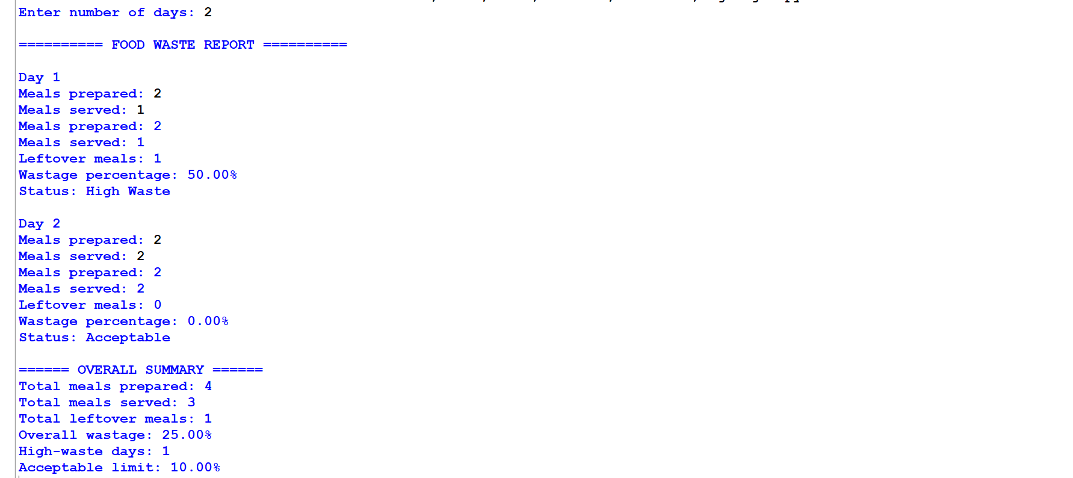
11. Conclusion
The Food Waste Monitoring System uses Python to track meals prepared, meals served, and leftover food over several days. It calculates daily and overall wastage percentages and identifies days that exceed the acceptable limit. The system helps kitchens, hostels, and cafeterias monitor food usage, improve meal planning, reduce unnecessary waste, and use resources more efficiently.

